Luis Cervantes Oropeza

CS333 Project 3

**Test name:** with CS333 PROJECT set to 0 in the MakeFile

**Test Description:** Correctly compiles and boots, usertests runs to completion with all tests passed

**Expected results:** Expected results is for this to pass.

**Test Output / Actual Results:**

Correctly compiles and boots

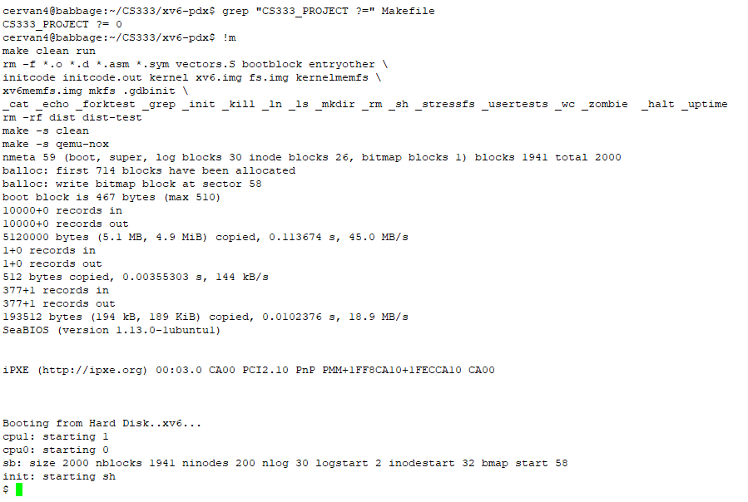

Usertests runs to completion with all tests passed**:**

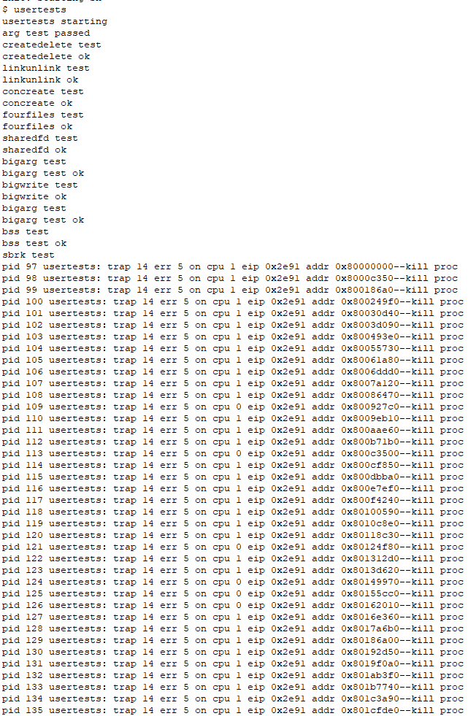

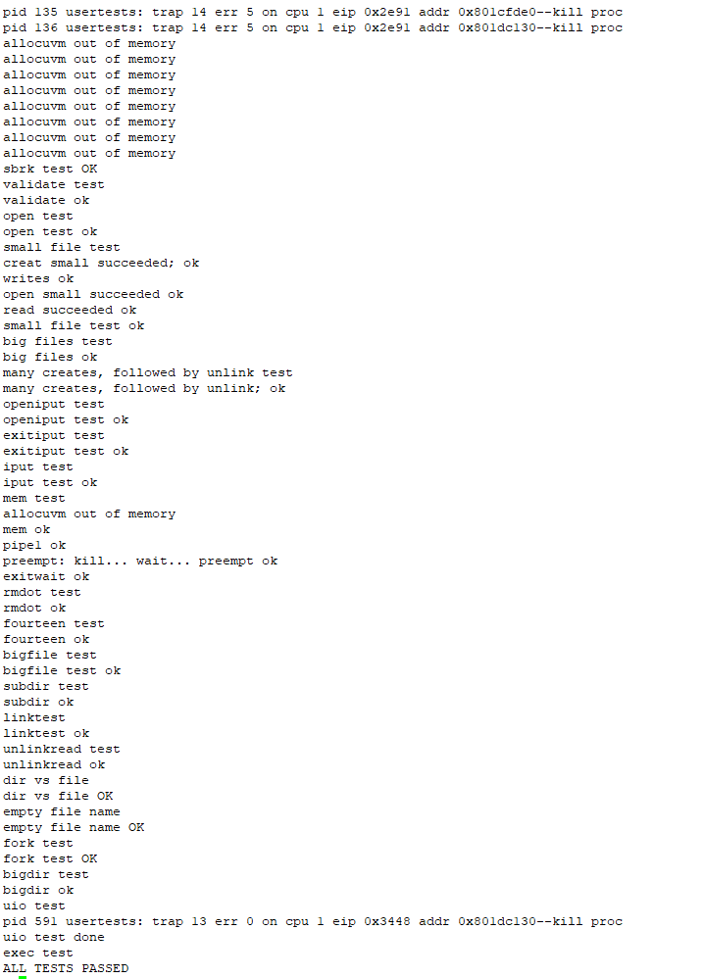

**Discussion:**

The results were as expected everything compiled and worked properly.

**Indication of Pass/Fail:**

This test Passed

**Test Name:** CS333 PROJECT set to 3 in the Makefile

**Test Description:** Correctly compiles and boots, usertests runs to completion with all tests passed

**Expected Results:** Expected results for this test is for it to pass

**Test Output / Actual Results:**

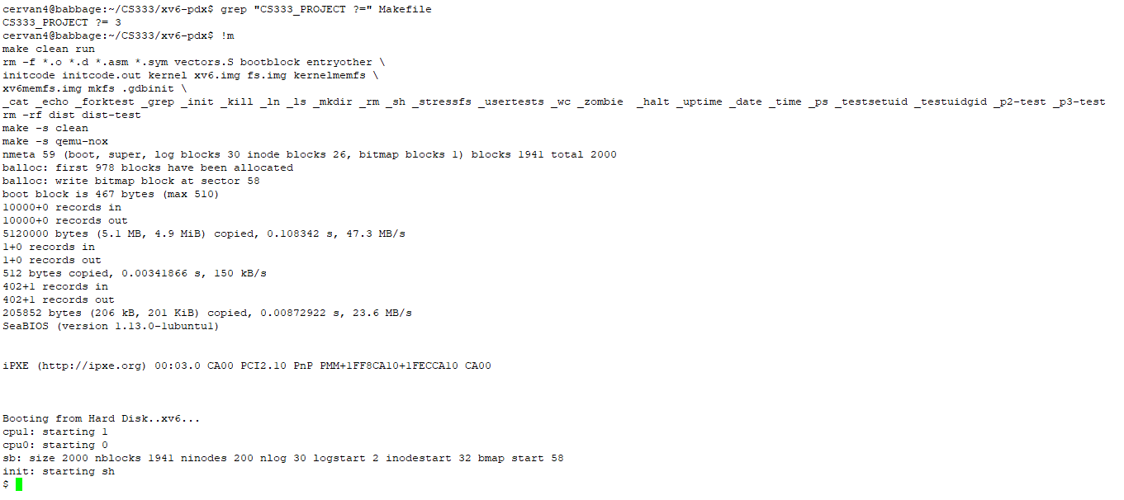

Usertests runs to completion with all tests passed

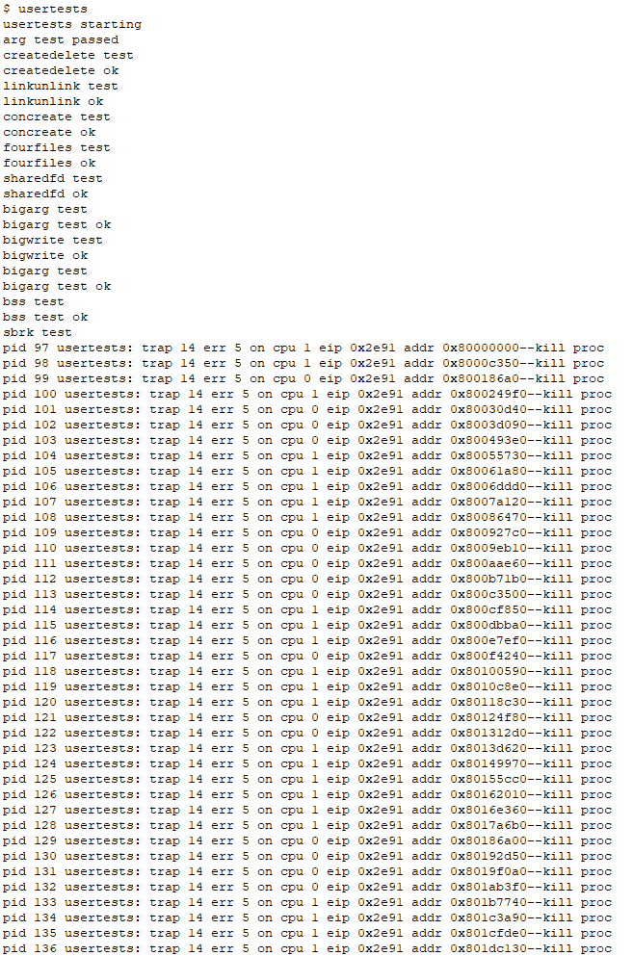

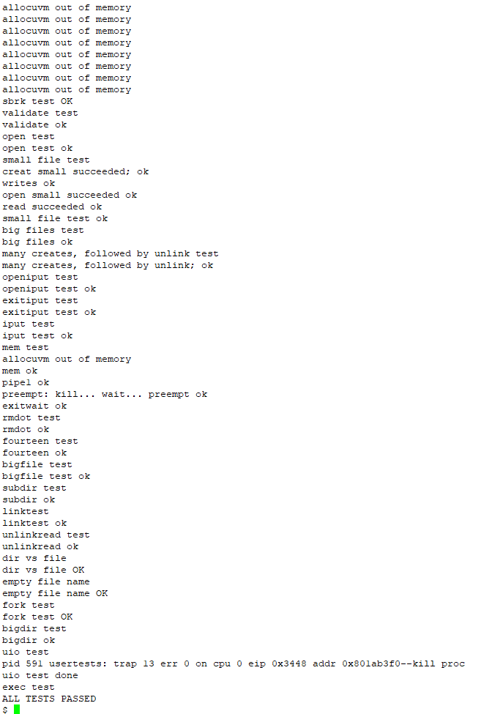

**Discussion:** The results were as expected everything compiled and worked properly.

**Indication of PASS/FAIL:** This test Passed

**Test Name:** All subsequent tests should be done with the CS333 P3 macro turned on, when CS333 PROJECT is set to 3 in the Makefile.

**Test Description:**

* Show the UNUSED list is correctly initialized after xv6 is fully booted,
* Show the UNUSED list is correctly updated when a process is allocated and deallocated.
* Demonstrate that round-robin scheduling is maintained.
* Show the SLEEPING list is correctly updated when a process sleeps and is woken up.
* Process Death
  + Show the kill() system call correctly causes a process to move to the ZOMBIE list. The kill user program can be used for this purpose as it invokes the kill() system call.
  + Show the exit() system call correctly causes a process to move to the ZOMBIE list.
  + Show the wait() system call correctly causes a process to move to the UNUSED list.
* Show the console command control -r, control -s, control -f, control -z are correct match to the format in the project description.

**Expected Results:** Expected results for this test is for it to pass all of the tests and get all of the values back correctly.

**Test Output / Actual Results:**

* Show the UNUSED list is correctly initialized after xv6 is fully booted,

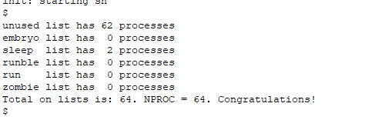

* Show the UNUSED list is correctly updated when a process is allocated and deallocated.

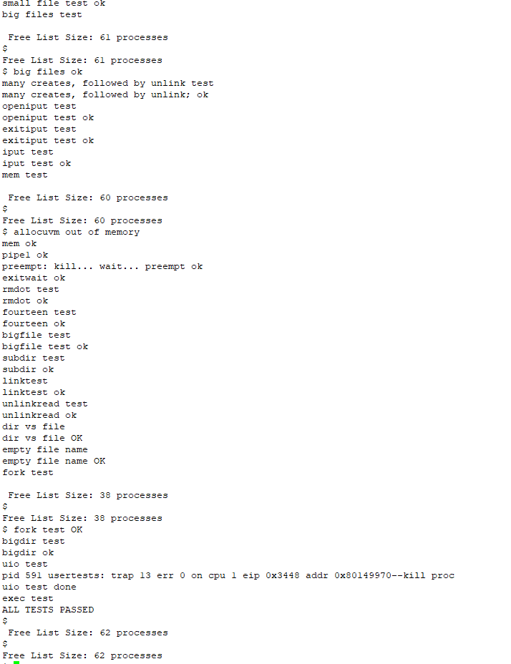

* Show the SLEEPING list is correctly updated when a process sleeps and is woken up.

**Discussion:** The results were as expected everything compiled and worked properly.

**Indication of PASS/FAIL:** This test Passed